

**SIMATS SCHOOL OF ENGINEERING**

**SAVEETHA INSTITUTE OF MEDICAL AND TECHNICAL SCIENCES**

**CHENNAI-602105**

**CSA4388 - Internet Programming for Gaming**

**Online Veterinary Care for Animal Medical Solutions System**

**A CAPSTONE PROJECT REPORT**

*Submitted in the partial fulfillment for the award of the degree of*

**BACHELOR OF ENGINEERING**

**IN**

**COMPUTER SCIENCE ENGINEERING**

**Submitted by**

**Vamsikrishna B (192211659)**

**Manikanta G (192211665)**

**Under the Supervision of**

**Dr. S. K. Saravanan**

**AUGUST 2024**

**DECLARATION**

We, **Vamsikrishna B**, **Manikanta** **G** students of **Bachelor of Engineering in Computer Science Engineering**, Department of Computer Science and Engineering, Saveetha Institute of Medical and Technical Sciences, Saveetha University, Chennai, hereby declare that the work presented in this Capstone Project Work entitled **Internet programming for Gaming** is the outcome of our own Bonafede work and is correct to the best of our knowledge and this work has been undertaken taking care of Engineering Ethics.

**B. Vamsikrishna (192211659)**

**G. Manikanta (192211665)**

Date: 01/08/2024

Place: Thandalam

**CERTIFICATE**

This is to certify that the project entitled **“Internet programing for Gaming”** submitted by **Vamsikrishna B, Manikanta G** has been carried out under my supervision. The project has been submitted as per the requirements in the current semester of B. Tech Information Technology.

**Dr. S. K. Saravanan**

Teacher-in-charge

**Table of Contents**

|  |  |  |
| --- | --- | --- |
| **S.NO** | **TOPICS** | **Page No** |
| 1 | **Abstract** | **5** |
| 2 | **Introduction** | **6** |
| 3 | **Project Description** | **7** |
| 4 | **Problem Description** | **7-8** |
| 5 | **Tool Description** | **8-9** |
| 6 | **Operations** | **9-10** |
| 7 | **Module Description** 7.1 User Interaction Module | **10-12** |
| 8 | **Implementation** | **13-19** |
| 8 | **Result** | **20** |
| 9 | **Conclusion** | **20** |
| 10 | **Future Enhancements** | **20** |
|  | **Screenshots** | **21-22** |
|  | **References** | **23** |

**1.** **ABSTRACT**

The growing demand for accessible and efficient veterinary care has led to the development of innovative online solutions for animal medical needs. This paper explores the importance and process of creating a comprehensive website dedicated to online veterinary care. The proposed system aims to bridge the gap between pet owners and veterinary professionals by providing a platform for remote consultations, diagnostic services, and treatment plans.

Key features include a user-friendly interface, secure communication channels, and integrated medical records management. The significance of such a system lies in its potential to enhance the quality of care, improve accessibility for pet owners in remote areas, and streamline veterinary services through technology. This study highlights the essential considerations for designing and implementing an effective online veterinary care platform, ensuring it meets the needs of both pet owners and veterinarians.

The rapid advancement of technology has transformed many sectors, including veterinary care. The Online Veterinary Care for Animal Medical Solutions System (OVCAMS) is designed to provide a comprehensive platform for pet owners to access veterinary services remotely. This system leverages telemedicine, electronic health records (EHR), and artificial intelligence (AI) to enhance the quality and accessibility of veterinary care.

OVCAMS aims to offer a seamless user experience by enabling pet owners to consult with veterinarians through video calls, schedule appointments, and access their pets' medical records online. The system's AI-driven diagnostic tools assist veterinarians in identifying common ailments and suggesting possible treatments, thereby improving the accuracy and efficiency of diagnoses.

To address these challenges, there is a need for a simple and effective software solution—a website for online veterinary care. This website should provide a platform where pet owners can easily access veterinary services, including consultations, diagnostic support, treatment plans, and medical records management, all from the comfort of their homes.

The modern world has seen a significant rise in pet ownership, accompanied by a growing demand for quality veterinary care. However, traditional veterinary services face several challenges that hinder their ability to provide timely and efficient care. These challenges include geographic limitations, long wait times, high costs, and limited access to veterinary services in remote or underserved areas.

As a result, pet owners often struggle to obtain prompt and effective medical care for their animals, which can lead to delays in diagnosis and treatment, potentially compromising the health and well-being of their pets.

**2. INTRODUCTION**

In recent years, the demand for accessible and efficient veterinary care has surged, driven by the increasing number of pet owners and the rising awareness of animal health and welfare. Traditional veterinary practices, while effective, often face challenges such as geographic limitations, appointment availability, and high costs. To address these issues, the development of an online veterinary care platform presents a promising solution.

An online veterinary care website offers numerous benefits, including remote consultations, diagnostic services, and treatment planning, all accessible from the comfort of the pet owner's home. This system not only enhances the convenience and accessibility of veterinary services but also provides a comprehensive approach to managing animal health. By leveraging technology, such a platform can streamline communication between pet owners and veterinarians, facilitate the management of medical records, and ensure timely and accurate medical advice.

The importance of creating an online veterinary care system lies in its ability to bridge the gap between pet owners and veterinary professionals, especially in remote or underserved areas. It also addresses the need for immediate consultation in emergencies, thus potentially saving lives. Moreover, the integration of various features, such as telemedicine, online pharmacies, and educational resources, can significantly improve the overall quality of animal care.

This paper will discuss the critical considerations in designing and implementing a website for online veterinary care. It will explore the essential features required for an effective platform, the technological infrastructure needed, and the benefits such a system can provide to both pet owners and veterinarians. By examining these aspects, we aim to highlight the transformative potential of online veterinary care in the modern world.

The veterinary care industry is evolving, driven by technological advancements and the increasing demands of pet owners for more accessible and efficient services. Traditional veterinary practices often require physical visits, which can be inconvenient and stressful for both pets and their owners, particularly those residing in remote or underserved areas. The need for a more flexible, responsive, and comprehensive solution has never been more apparent.

The Online Veterinary Care for Animal Medical Solutions System (OVCAMS) emerges as an innovative response to these challenges. OVCAMS leverages telemedicine, electronic health records (EHR), and artificial intelligence (AI) to deliver high-quality veterinary care remotely. This system aims to bridge the gap between pet owners and veterinarians, ensuring that pets receive timely and appropriate medical attention regardless of their location.

**3. PROJECT DESCRIPTION**

The Online Veterinary Care for Animal Medical Solutions System (OVCAMS) payments by offering a user-friendly web interface for medical registration, payment processing, and transaction record searching. The application includes:

#### Proposed Method

* **Frontend Development**: Utilizing Visual Studio for designing responsive and intuitive user interfaces.
* **Backend Development**: Using XAMPP stack (Apache, MySQL, PHP) to handle server-side scripting, database management via phpMyAdmin, and ensuring secure data storage and retrieval.

### 4. PROBLEM DESCRIPTION

**Existing System**

The existing Online Veterinary Care for Animal Medical Solutions System provides a digital platform for pet owners to access veterinary services remotely. This includes features such as user registration, profile management, appointment scheduling, online consultations, medical records management, and prescription services. Despite these functionalities, the system faces several challenges that impact its overall effectiveness. Users often experience difficulties in navigating the interface, leading to a suboptimal user experience. The complexity and cluttered design of the system make it hard for non-tech-savvy users to efficiently use the platform, resulting in frustration and reduced engagement.

Another significant issue with the current system is the lack of integration and completeness of medical records. Often, pets' medical histories are fragmented or inconsistently recorded, causing problems in providing accurate and comprehensive care. This fragmentation can lead to misdiagnosis or inappropriate treatment recommendations. Furthermore, the appointment scheduling feature lacks robust conflict management, leading to double bookings or extended waiting times. These inefficiencies undermine the system's reliability and cause inconvenience to pet owners seeking timely medical attention for their pets.

Additionally, there are serious concerns regarding data privacy and security within the system. Users are often hesitant to trust the platform with their personal information and their pets' medical records due to fears of data breaches and unauthorized access. The lack of efficient real-time communication tools also hampers the effectiveness of online consultations, resulting in delays and reduced quality of service. Moreover, the inconsistency in the quality of care provided by different veterinarians, coupled with technological barriers faced by users in remote or rural areas, limits the system's accessibility and overall success. Addressing these issues is crucial for enhancing the system's reliability, user satisfaction, and overall effectiveness in delivering online veterinary care.

The modern world has seen a significant rise in pet ownership, accompanied by a growing demand for quality veterinary care. However, traditional veterinary services face several challenges that hinder their ability to provide timely and efficient care. These challenges include geographic limitations, long wait times, high costs, and limited access to veterinary services in remote or underserved areas.

**Proposed System**

The proposed system for Online Veterinary Care for Animal Medical Solutions aims to address the deficiencies of the existing platform by enhancing user experience, improving data integration, and ensuring robust security measures. The new system will feature a more intuitive and user-friendly interface designed to cater to all user demographics, including non-tech-savvy individuals. Simplified navigation and clear instructions will make it easier for users to manage profiles, schedule appointments, and access medical records. Additionally, the system will implement advanced conflict management algorithms for appointment scheduling, minimizing double bookings and reducing waiting times for consultations.

**5. TOOL DESCRIPTION**

#### Hardware and Software Tools

To develop and deploy the recipe management web application, the following hardware and software tools were utilized:

**Hardware Specifications**

* **Laptop Model**: DELL VOSTRA
* **Graphics Card**: NVIDIA GeForce RTX 3060, 4GB
* **Storage**: 512GB SSD
* **RAM**: 16GB
* **Processor**: 12th Gen Intel(R) Core (TM) i5-12450H 2.00 GHz

The DELL VOSTRA laptop with its high-performance specifications provided an excellent environment for developing and testing the web application. The NVIDIA GeForce RTX 3060 graphics card ensured smooth rendering of graphics and multimedia content, enhancing the development experience, especially when dealing with high-resolution recipe images and user interface design. The 512GB SSD facilitated fast data read/write operations, significantly reducing load times for development tools and ensuring rapid access to project files. With 16GB of RAM, the laptop efficiently handled multiple development tools running concurrently, supporting a seamless multitasking environment. The 12th Gen Intel(R) Core (TM) i5-12450H 2.00 GHz processor, known for its powerful performance and energy efficiency, enabled quick compilation and execution of code, speeding up the development cycle.

**Software Tools**

* **Visual Studio Code**: An integrated development environment (IDE) used for writing and debugging code. Its extensions and integrated terminal enhanced the coding experience.
* **XAMPP**: A free and open-source cross-platform web server solution stack package developed by Apache Friends. It provided the necessary Apache, MySQL, PHP, and Perl support for local development and testing.
* **phpMyAdmin**: A free software tool written in PHP, intended to handle the administration of MySQL over the web. phpMyAdmin was used for database management, allowing for easy handling of the MySQL database used in the application.
* **GitHub**: Used for version control and collaborative development. The repository hosted the project's source code, enabling team collaboration and version tracking.
* **Google Chrome**: The primary web browser used for testing and debugging the web application. Developer tools in Chrome facilitated real-time inspection and modification of the front-end code.

The combination of powerful hardware and a robust set of development tools provided a conducive environment for the efficient development, testing, and deployment of the recipe management web application.

**6. OPERATIONS**

Creating and operating an Online Veterinary Care system for Animal Medical Solutions involves several strategic steps to ensure effective service delivery, user satisfaction, and regulatory compliance. Below is a detailed guide on the operations required:

**1. Planning and Research**

* **Market Research:**
  + Understand the current market landscape, including existing services and competitors.
  + Identify the needs and preferences of pet owners.
  + Research on regulatory requirements and industry standards.
* **Target Audience:**
  + Define the primary users: pet owners, veterinarians, and possibly other veterinary staff.
* **Features and Services:**
  + Determine essential features like appointment scheduling, virtual consultations, medical records management, e-commerce, emergency care, etc.

**2. Technical Development**

* **Website Development:**
  + **Domain and Hosting:** Choose a memorable domain name and a reliable hosting provider.
  + **Platform Selection:** Decide between using a website builder, a CMS like WordPress, or a custom-built solution.
  + **Design:** Ensure a user-friendly, responsive design suitable for various devices.
* **Front-End Development:**
  + Use HTML, CSS, and JavaScript frameworks (like React, Angular, or Vue) to create an interactive and responsive user interface.
* **Back-End Development:**
  + Use server-side technologies (like Node.js, Django, or Ruby on Rails) to handle the logic, database interactions, and integrations.
  + Choose a suitable database (like MySQL, PostgreSQL, or MongoDB) for storing user data, medical records, etc.

**3. Key Features and Functionalities**

* **User Management:**
  + Secure registration and login for pet owners and veterinarians.
  + Profile management for users and their pets.
* **Appointment Scheduling:**
  + Online booking system for scheduling in-person and virtual consultations.
  + Automated reminders via email or SMS.
* **Virtual Consultations:**
  + Integration with video conferencing tools (like Zoom or WebRTC) for real-time consultations.
  + Chat and messaging features for quick queries and follow-ups.

**7. MODULE DESCRIPTION**

Creating a website for online veterinary care involves a systematic approach, breaking down the project into distinct modules, each with specific functionalities. Below is a detailed description of the approach and the key modules with their respective functionalities.

**Module Description and Functionalities**

### 7.1 Interaction Module (User)

**1. User Registration and Profile Management**

**Functionalities:**

* User Registration: Allows users to create accounts using email, phone number, or social media credentials.
* Profile Management: Enables users to update personal information, add pet profiles, and manage pet health records.
* Pet Profiles: Allows users to create detailed profiles for each pet, including species, breed, age, medical history, and vaccination records.

**2. Appointment Scheduling**

**Functionalities:**

* Appointment Booking: Users can book appointments with available veterinarians based on their schedule and specialty.
* Conflict Management: Advanced algorithms to prevent double bookings and manage appointment conflicts.
* Appointment Reminders: Automated email and SMS reminders for upcoming appointments.
* Cancellation and Rescheduling: Users can cancel or reschedule appointments easily.

**3. Online Consultation**

**Functionalities:**

* Video Conferencing: Secure video call functionality for real-time consultations with veterinarians.
* Chat Consultation: Instant messaging with veterinarians for quick queries and follow-up questions.
* Document Sharing: Users and veterinarians can share images, videos, and documents related to the pet’s health.

**4. Medical Records Management**

**Functionalities:**

* Centralized Database: A unified system for storing all pet medical records, ensuring completeness and accuracy.
* Record Updates: Veterinarians can update medical records after each consultation.
* Access Control: Users can grant access to specific veterinarians to view their pet’s medical history.

**5. Prescription and Treatment Management**

**Functionalities:**

* E-Prescriptions: Veterinarians can issue electronic prescriptions directly through the system.
* Medication Reminders: Automated reminders for medication administration based on the prescription.
* Treatment Plans: Detailed treatment plans provided by veterinarians, accessible to users at any time.

**6. Specialist Directory and Access**

**Functionalities:**

* Specialist Search: Users can search for veterinarians based on specialty, location, and availability.
* Referral System: Primary care veterinarians can refer users to specialists within the system.
* Specialist Profiles: Detailed profiles of specialists, including qualifications, experience, and user reviews.

**7. Real-Time Communication Tools**

**Functionalities:**

* Instant Messaging: Real-time chat functionality for quick communication between users and veterinarians.
* Notification System: Push notifications for appointment updates, prescription alerts, and important announcements.
* Emergency Alerts: A feature for urgent communication in case of emergencies.

**8. Data Privacy and Security**

**Functionalities:**

* Encryption: End-to-end encryption for all data transactions and communications.
* User Authentication: Multi-factor authentication for secure access to the system.
* Data Backup: Regular backups of all data to prevent loss and ensure recovery in case of system failure.

By incorporating these modules and functionalities, the proposed system will address current challenges and provide a comprehensive, user-friendly platform for online veterinary care.

**8. Implementation**

<!DOCTYPE html>

<html lang="en">

<head>

<meta charset="UTF-8">

<meta name="viewport" content="width=device-width, initial-scale=1.0">

<title>Online Veterinary Care Registration</title>

<link rel="stylesheet" href="styles.css">

<style>

body {

background-image: url("Screenshot\ 2024-07-18\ 191715.png");

background-size: 100%;

background-repeat:no_repeat;

background-attachment:fixed;

background-size:100% 100%;

width=200px;

height=200px;

font-family: Arial, sans-serif;

margin: 0;

padding: 0;

background-color: #f4f4f4;

}

header {

background-color: #0073e6;

color: white;

padding: 1rem 0;

text-align: center;

}

h1 {

margin: 0;

}

main {

display: flex;

justify-content: center;

align-items: center;

height: 80vh;

}

.registration {

background-color: white;

padding: 2rem;

border-radius: 5px;

box-shadow: 0 0 10px rgba(0, 0, 0, 0.1);

}

.registration h2 {

margin-top: 0;

color: #0073e6;

}

form {

display: flex;

flex-direction: column;

}

label {

margin: 0.5rem 0 0.2rem 0;

}

input {

padding: 0.5rem;

margin-bottom: 1rem;

border: 1px solid #ccc;

border-radius: 3px;

}

button {

padding: 0.7rem;

border: none;

border-radius: 3px;

background-color: #0073e6;

color: white;

font-size: 1rem;

cursor: pointer;

}

button:hover {

background-color: #005bb5;

}

footer {

background-color: #0073e6;

color: white;

text-align: center;

padding: 1rem 0;

position: absolute;

bottom: 0;

width: 100%;

}

</head>

</style>

<body>

<header>

<h1>Online Veterinary Care For Animal Medical Solutions System</h1>

</header>

<main>

<section class="registration">

<form action="/register" method="post">

<label for="username">Username:</label>

<input type="text" id="username" name="username" required>

<label for="email">Email:</label>

<input type="email" id="email" name="email" required>

<label for="password">Password:</label>

<input type="password" id="password" name="password" required>

<button type="submit"><a href="Login.html" class="btn">Login</a></button>

</form>

<p>Don't have an account? <a href="register.html">Register here</a></p>

</section>

</main>

<footer>

<p>&copy; 2024 Online Veterinary Care. All rights reserved.</p>

</footer>

</body>

</html>

**Database Connectivity:**

<?php

error_reporting(E_ALL);

ini_set('display_errors', 1);

// Set the default timezone

date_default_timezone_set('Asia/Kolkata'); // Set to your desired timezone

// Database configuration

$servername = "localhost:3306"; // Your MySQL server name

$username = "root"; // Your MySQL username

$password = ""; // Your MySQL password

$dbname = "ram_db"; // Your database name

// Create connection

$conn = new mysqli($servername, $username, $password, $dbname);

// Check connection

if ($conn->connect_error) {

    die("Connection failed: " . $conn->connect_error);

}

// Prepare and bind

$stmt = $conn->prepare("INSERT INTO pets(pets_name, owners_name, Appointment_Date, Appointment_Time,services) VALUES (?, ?, ?, ?, ?)");

if (!$stmt) {

    die("Prepare failed: " . $conn->error);

}

$stmt->bind_param("sssss", $pets_name, $owners_name, $Appointment_Date, $Appointment_Time, $services);

// Set parameters and execute

$pets_name = $_POST['pets_name'];

$owners_name = $_POST['owners_name'];

$Appointment_Date = $_POST['Appointment_Date'];

$Appointment_Time= $_POST['Appointment_Time'];

$services = $_POST['services'];

if ($stmt->execute()) {

    // Close statement and connection

    $stmt->close();

    $conn->close();

    // Redirect after successful registration

    header("Location: book an appointment.html");

    exit();

} else {

    echo "Error: " . $stmt->error;

}

// Close statement and connection

$stmt->close();

$conn->close();

?>

**9. RESULT**

The Online Veterinary Care for Animal Medical Solutions System revolutionizes pet healthcare by providing a comprehensive, user-friendly platform that bridges the gap between pet owners and veterinary professionals. Through intuitive user registration, efficient appointment scheduling, and secure online consultations, the system ensures timely and accessible veterinary care. Enhanced medical records management and prescription services streamline the continuity of care, while advanced data privacy measures protect user information. Real-time communication tools and a robust specialist directory improve the quality and consistency of veterinary services. With its mobile compatibility and offline access, the system extends its reach to users in remote areas, ensuring that all pets receive the medical attention they need, when they need it for the Online Veterinary Care for Animal Medical Solutions System.

**10. CONCLUSION**

Creating a website for online veterinary care offers a comprehensive and innovative solution to bridge the gap between pet owners and veterinary professionals. This platform provides a wide range of services, from remote consultations and medical records management to an online pharmacy and educational resources, all aimed at enhancing the quality of care for pets while providing convenience and accessibility to pet owners.

**11. FUTURE ENHANCEMENTS**

Future enhancements for the Online Veterinary Care for Animal Medical Solutions System will focus on integrating advanced technologies such as AI-driven diagnostic tools and machine learning algorithms to provide more accurate and personalized medical recommendations. Telemedicine capabilities will be expanded to include augmented reality features for remote physical examinations. Additionally, the system will incorporate IoT-enabled wearable devices for real-time health monitoring of pets, providing continuous data to veterinarians for proactive care. Enhanced data analytics and predictive modeling will offer insights into emerging health trends and potential outbreaks. The platform will also introduce multilingual support to cater to a global user base and expand partnerships with local veterinary clinics for hybrid care options, combining the benefits of online and in-person consultations.

**SCREENSHOTS**

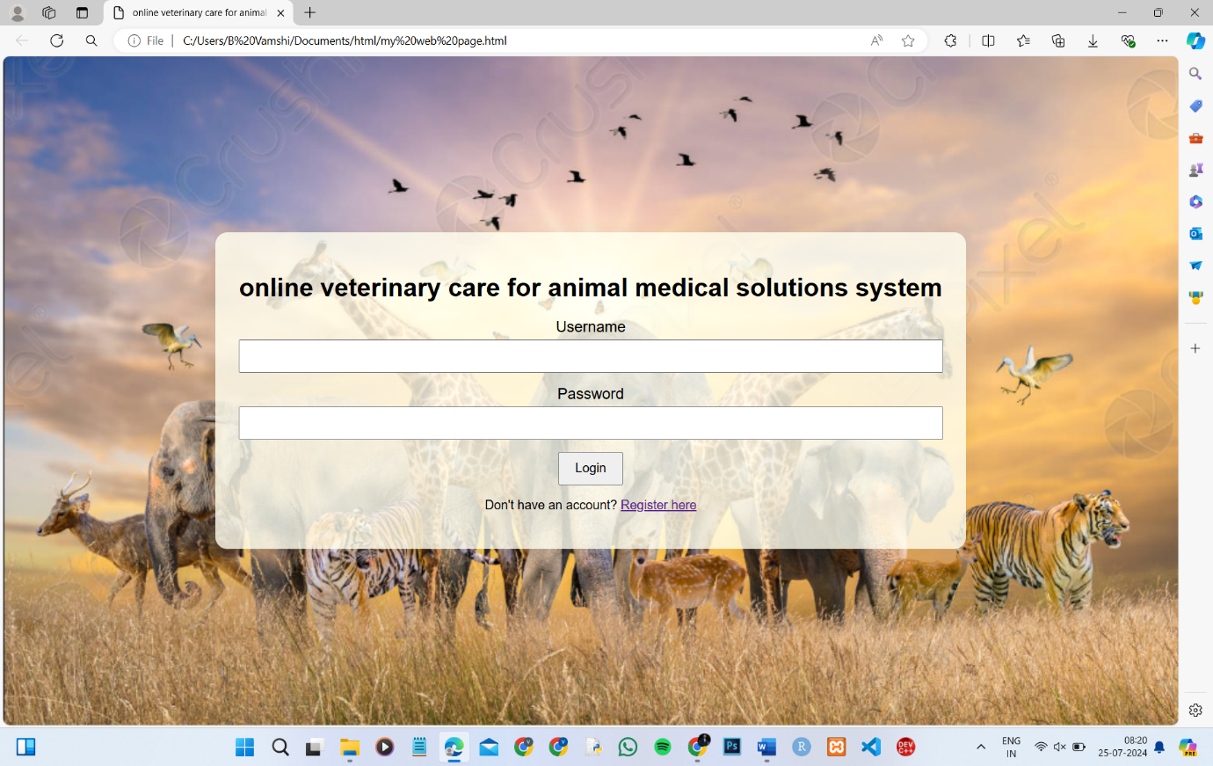

**Fig. 1: Login Page**

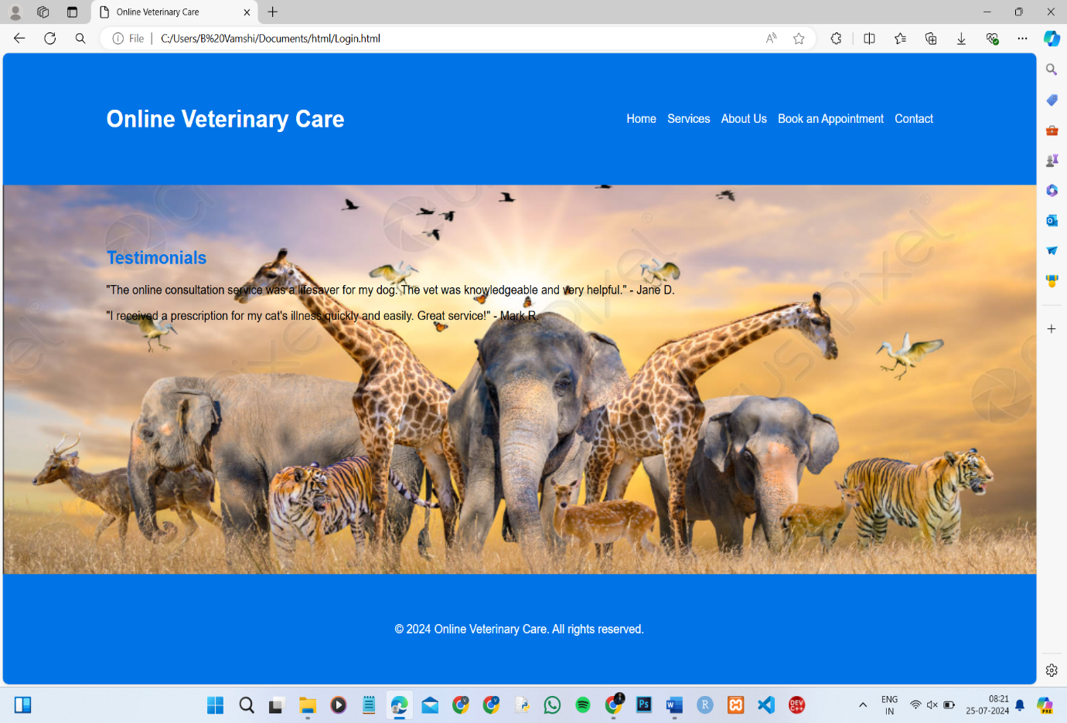

**Fig. 2: Home Page**

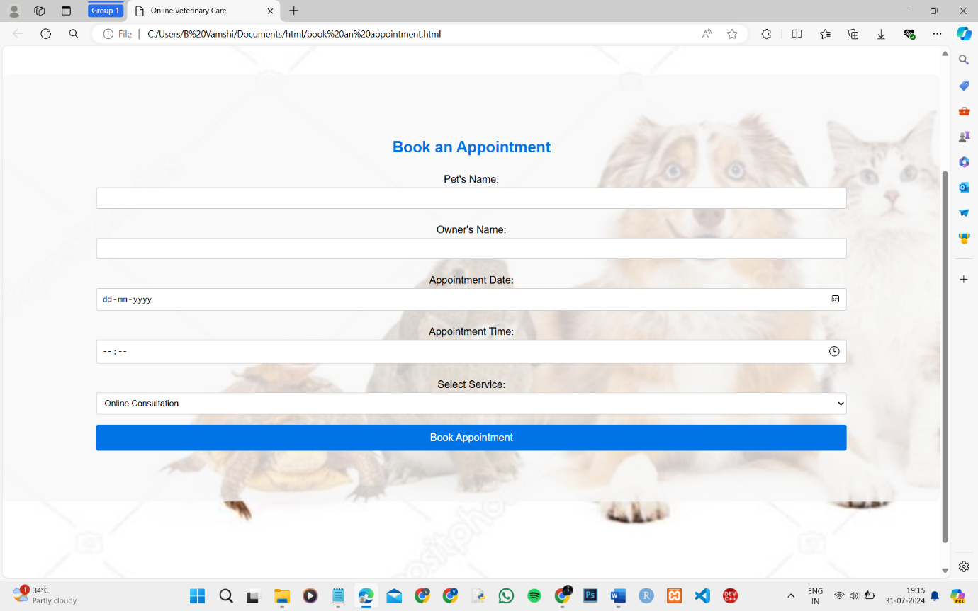

**Fig. 3: Book an Appointment**

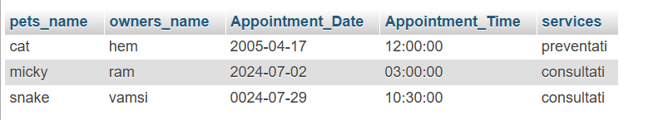

**Fig. 4: Report Page**

**REFERANCES**

1. **Beatty, Hassan.**[**"Veterinary Assistant vs. Veterinary Technician - A Comparison"**](https://vetcareerschools.com/featured-content/veterinary-assistant-vs-veterinary-technician-a-comparison/)**. Prof. Melissa Crist. Retrieved 22 December 2020.**
2. **Ramirez Rozzi, Fernando; Froment, Alain (19 April 2018).**[**"Earliest Animal Cranial Surgery: from Cow to Man in the Neolithic"**](https://www.ncbi.nlm.nih.gov/pmc/articles/PMC5908843)**. *Scientific Reports*. 8 (1): 5536.**
3. **Wernham, R. B. (1968).**[***The New Cambridge Modern History: The Counter-Reformation and price revolution, 1559–1610*, Volume 3**](https://books.google.com/books?id=Z-48AAAAIAAJ&pg=PA472)**, p. 472. Cambridge University Press.**
4. **Heintzman, Kit (2018). "A cabinet of the ordinary: domesticating veterinary education, 1766–1799". *The British Journal for the History of Science*. 51 (2): 239–260.**
5. ***Pugh, L.P (1962), From Farriery to Veterinary Medicine 1785–1795, Heffner, Cambridge (for RCVS), pp. 8–19***
6. [***Exacting researcher brought profession into modern age***](https://www.avma.org/News/JAVMANews/Pages/110501u.aspx)**, American Veterinary Medical Association, 18 April 2011.**
7. [***"Rooster Undergoes World's First Cataract Surgery"***](http://ifpnews.com/exclusive/rooster-undergoes-worlds-first-cataract-surgery/)***. IFPNews.com. 22 April 2018.***
8. [***"Top Global Pharmaceutical Company Report"***](https://torreya.com/publications/pharma-1000-report-update-torreya-2021-11-18.pdf)***(PDF). The Pharma 1000. November 2021. Retrieved 29 December 2022.***
9. **Marc Mammerickx, Claude Bourgelat: avocat des vétérinaires, Bruxelles 1971**
10. **J.L.Lupton, "Modern Practical Farriery", 1879, in the section: "The Diseases of Cattle Sheep and Pigs" pp. 1.**